NAME: ________________________________ Pd.____
1-5

Anatomy & Physiology
Ch. 1 - The Human Body: An Orientation

Language of Anatomy (pp. 11- 17; 20)

- Define the directional terms and the anatomical planes and sections used to locate parts of the human body.
- every directional term has an opposite to explain exactly where one body structure is in relation to another
- we must have an initial reference point when using directional terms
  - This reference point is often the midline of the body or the midline of a part.

- Define each of the directional terms.

cranial ________________________________________________________________
deep ________________________________________________________________
distal ________________________________________________________________
dorsal (posterior) ________________________________________________________________
inferior (caudal) ________________________________________________________________
intermediate ________________________________________________________________
lateral ________________________________________________________________
medial ________________________________________________________________
proximal ________________________________________________________________
superficial ________________________________________________________________
superior (cranial) ________________________________________________________________
ventral (anterior) ________________________________________________________________

- Complete the following using the most appropriate directional term.

1. The thumb is __________________________________ to the fingers.
2. The brain is __________________________________ to the spinal cord.
3. The breastbone is __________________________________ to the spine.
4. The lungs are __________________________________ to the stomach.
5. The wrist is __________________________________to the hand.
6. The trachea (windpipe) is ______________________________ to the spine.
7. The nose is __________________________________to the cheekbones.
8. The fingers are __________________________________ to the elbow.
9. The skin is __________________________________to the muscles.
10. The abdomen is __________________________________to the chest.
- Body planes and sections
1-5
- when looking at the internal structures of the body, it is necessary to make a section or cut
- when a section is made through the body wall or through an organ, it is made along an imaginary line called a plane.
- since the body is 3-dimensional, there are three types of body planes or sections that lie at right angles to one another

- Identify each of the planes on the diagrams.

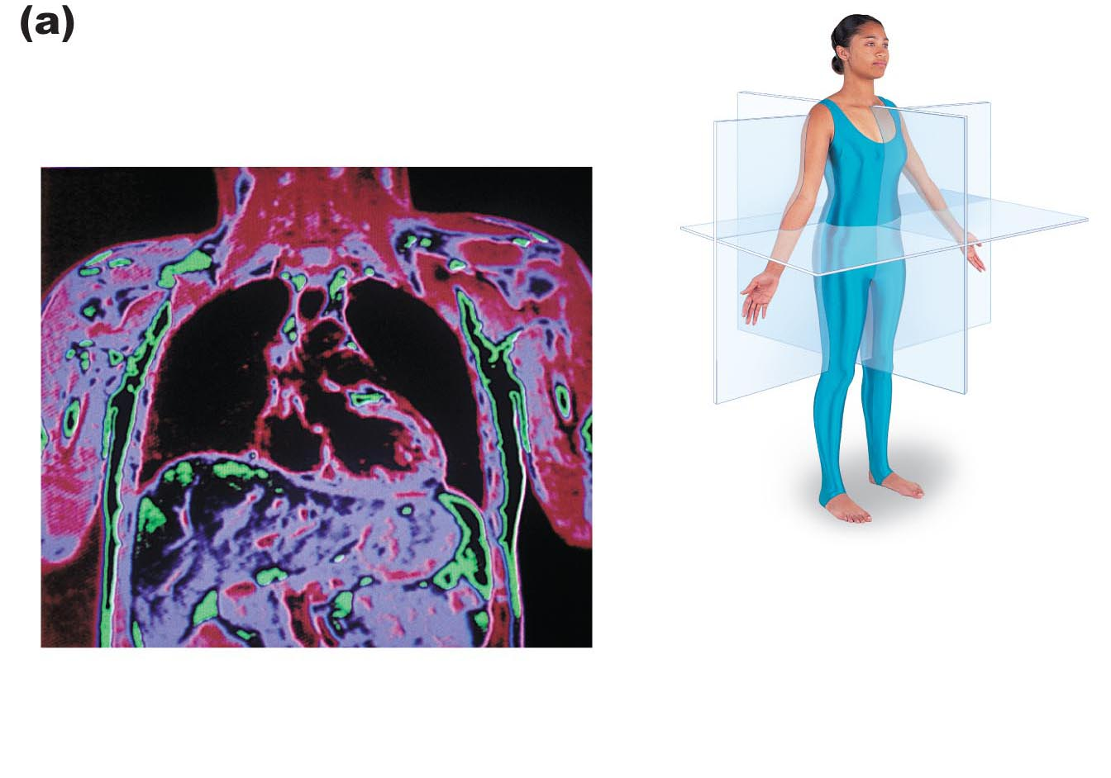
(not shown)
NS.
C.
B.
A.
______ sagittal plane
______ midsagittal (median)
______ parasagittal
______ frontal plane (coronal)
______ transverse section (cross section)
______ oblique plane
______ cuts body into superior/inferior
______ cuts body into left/right
______ cuts body into ventral/dorsal
- Describe the principal body cavities and the organs they contain.

- the body has two sets of internal cavities that provide different degrees of protection to the organs within them
- They contain, protect, separate, and support internal organs (viscera; visceral organs)

- dorsal cavities

- cranial cavity – contains ______________________________________________

- vertebral (spinal) cavity – contains _____________________________________

- ventral cavities - large anterior cavities that house/contain the viscera
- thoracic cavity – contains _____________________________________________
- pleural cavity – contains ______________________________________________
- mediastinum – contains _______________________________________________
- pericardial cavity – contains ___________________________________________

- abdominopelvic cavity
1-5
- abdominal cavity (abdomino = belly)
contains _________________________________________________
_________________________________________________
- pelvic cavity (pelvic = basin)
contains _________________________________________________
_________________________________________________

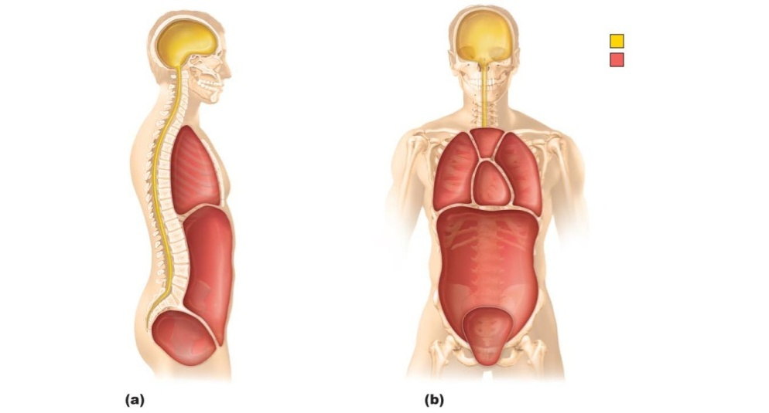
J.
I.

G
H
F
B
A
G
D
E
E
D
C
A
______ abdominal cavity
______ dorsal cavity
______ mediastinum
______ pelvic cavity
______ pericardial cavity
______ pleural cavity
______ thoracic cavity
______ ventral cavity

- Serous Membrane (serosa) in the ventral cavity

- thin, double-layered membrane separated by serous fluid
- parietal serosa lines internal body walls
- visceral serosa covers the internal organs
- serous fluid secreted by both membranes allows the organs to _________________________________
___________________________________________________________________________________
outer balloon wall (comparable to ______)
air (comparable to ______)
inner balloon wall (comparable to ______)

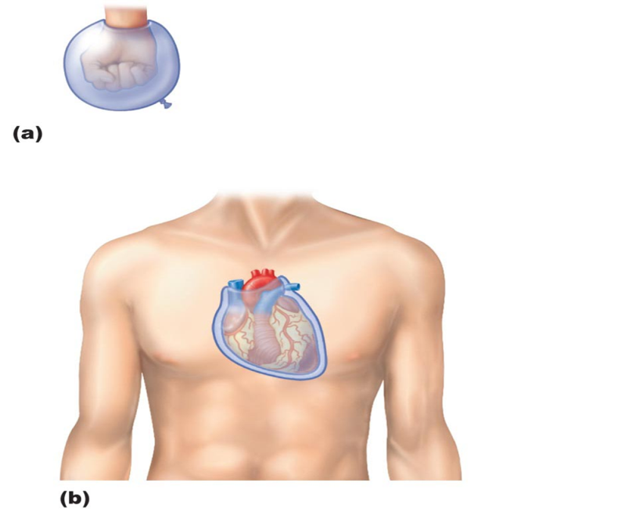
Note:
The lung and pleural cavity is also surrounded by serous membranes but are named using the root “pleura” in place of serosa
  - parietal pleura
  - visceral pleura
  - pleural cavity
  - pleural fluid

______ pericardium (serosa)
______ pericardial space
______ pericardium (serosa)
A - visceral serosa
B - serous cavity; contains serous fluid
C - parietal serosa

1-5
- Abdominopelvic Regions and Quadrants

      - four quadrant system
- Divisions used primarily by medical personnel

Locate and name the divisions of the four quadrant system.
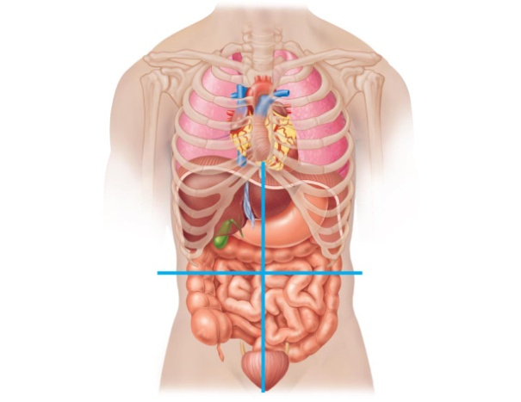
- __________________________________(_______)
- __________________________________(_______)
- __________________________________(_______)
- __________________________________(_______)
3
4
1

2

  - nine region system
- Nine divisions used primarily by anatomists

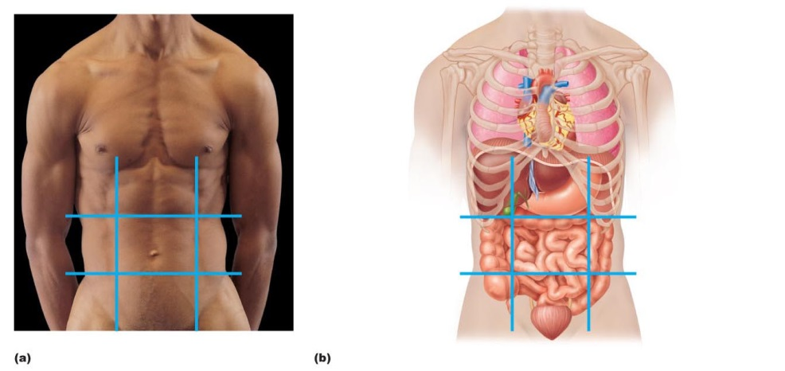

9
8
7
6
5
4
2
1
3
5
9
8
2
6
3
7
4
1

Locate and name the divisions of the nine region system.
List other noted body cavities:
_____________________
_____________________
_____________________
_____________________
_____________________
_____________________
- _________________________________________________
- _________________________________________________
- _________________________________________________
- _________________________________________________
- _________________________________________________
- _________________________________________________
- _________________________________________________
- _________________________________________________
- _________________________________________________

